Software Requirement Specification
Version No.1
Date: 1-02-11
Project Name: WebStore Application
Project Code:

Copyright Notice
The contents of this document are proprietary to <HCL Technologies LTD>. and shall not be disclosed, disseminated, copied, or used except for purposes expressly authorized in writing by <HCL Technologies LTD >.

Revision History
Version No | Date | Prepared by / Modified by | Significant Changes
1 | 1-02-11 | Deepika, Sudha Giriprasad, | Identified requirements of the application
2. | 7-02-11 | Deepika | Modified the requirements and Screen prototypes, tables and ER diagram are added
3. | 16-02-11 | Deepika | Added class diagrams, sequential  flow diagrams and use case  diagrams
4. | 17-02-11 | Deepika,Giri | Modified operational concepts  And scenarios, constrains and  References
5. | 24-02-11 | Deepika | Removed design requirements  from SRS.

Glossary
Abbreviation | Description
Table Of Contents

1 Introduction 5
1.1 Purpose 5
1.2 Scope 5
2 Overview of the Document 5
3 System Context 6
3.1 Product Perspective 6
3.1.1 System Overview & Context Diagram 6
3.1.2 Operational Concepts and Scenarios 7
3.1.3 System Interface 9
3.1.4 Memory Constraints 10
3.1.5 Site Adaptation Requirements 10
3.2 Product Functions 10
3.3 Constraints 10
3.4 Assumptions and Dependencies 11
3.5 Apportioning of Requirements 11
4 Specific Requirements 11
4.1 Organizational Requirements 11
4.2 Business requirements 11
4.3 User Requirements 11
4.4 External Interface Requirements 12
4.5 Functional Requirements / System Features 17
4.6 Performance Requirements 29
4.7 Acceptance Criteria 29
4.8 Logical Database Requirements 30
4.9 Design Constraints 33
4.10 Testing Requirements 34
4.11 Compliance to Standards 38
4.12 Software System Attributes 38
5 Derived Requirements 38
6 Validation 38
6.1 Validation strategy 38
6.2 Validation criteria 39
6.3 Validation Constraints 39
7 References 39

1 Introduction

Purpose
This document describes the online shopping portal functionality. With this portal user can navigate through a web-site where a user can do shopping online.

Scope
Many websites on internet are providing online shopping facilities. The web store online shopping website is generic enough to directly support all types of products/categories. Also features a fully functional cart which simultaneously stores products as well as items.
It Represents the commodities for sale under the below mentioned classifications:
a. Catalog
b. Category
c. Sub-Category
d. Product/Item
In addition it also offers shopping categories like IPods at reasonable prices and mobile phones of all major brands like Nokia, Samsung, Sony Ericsson and LG are offered online.

Overview of the Document
This document describes the online shopping portal functionality. With this portal user can navigate through a user can do shopping online. This web-site allows a new user to register with the web-site and provides cart for shopping. A registered user can do shopping by logging-in to his/her account.

System Context

Product Perspective
Car Audio & Video, TV & Video, Home Theater & Audio, MP3 & Portable, Cameras & Camcorders are the products available in the online Web Store portal where the customers can select the products for buying. The products which are available in the shopping portal are independent and totally self contained.

System Overview & Context Diagram

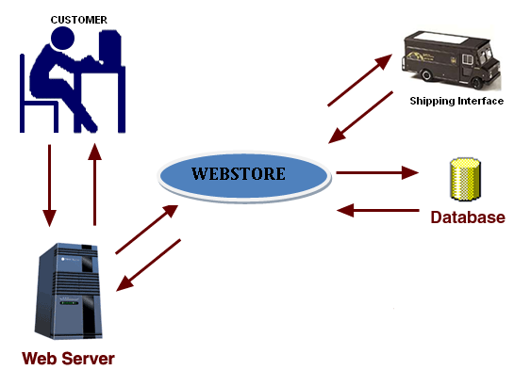

Operational Concepts and Scenarios

REQ-NO | Description
REQ-101 | User clicks on Sign-In link
REQ-102 | User enters username
REQ-103 | User enters password
REQ-104 | User clicks on Login button after entering correct username and password
REQ-105 | User navigates to respective page by clicking on any one of the links provided on top of the Login page.
REQ-201 | User clicks on Create an account now link in Login page and User enters Registration page
REQ-202 | User enters the username whichever username he wants
REQ-203 | User enters the password whichever password he wants
REQ-204 | User confirms his password by entering the same password which he/she enters in password field
REQ-205 | User enters his first name
REQ-206 | User enters his last name
REQ-207 | User enters his Date Of Birth
REQ-208 | User enters his Email-ID
REQ-209 | User enters his address
REQ-210 | User enters his phone number
REQ-211 | User enters his city name
REQ-212 | User enters his state name
REQ-213 | User enters the pin code
REQ-214 | User enters his country name
REQ-215 | User clicks on Register button after entering valid data
REQ-216 | User navigates to respective page by clicking on any one of the links provided on top of the registration page.
REQ-301 | User clicks on My Account link after logging in to see the profile.
REQ-302 | User updates his/her information/details/profile
REQ-303 | User can Sign-out from his/her account and can navigate to Home page, Cart page etc.
REQ-401 | User clicks on Home link. A page will be displayed showing all the available Catalogs.
REQ-402 | User selects any Catalog by clicking on a particular catalog image/name and all the available Categories under the selected catalog will be displayed.
REQ-403 | User selects a category from the resulting categories list by clicking on that particular category image/name and all the products/items under the selected category will be displayed.
REQ-404 | User selects a product/item from the resulting products/items list just by clicking on the image/name of that particular product/item
REQ-405 | User navigates to respective page by clicking on any one of the links provided on top of the Home page.
REQ-501 | User clicks on Add to Cart icon of the selected product to add it to cart.
REQ-502 | User can get his/her Cart after logging in also, if he adds items to Cart before logging in. But the user cannot get his/her Cart if he logs in after he/she logs out.
REQ-503 | User navigates to respective page by clicking on any one of the links provided on top of the Cart page and user can navigate to Home page by clicking on Keep Shopping icon in cart page.
REQ-601 | User can update the cart by clicking on Update button, if he/she made any changes to cart like changing the quantity of a product etc.
REQ-701 | User removes the selected product from cart by clicking on remove
REQ-801 | User clicks on Checkout icon to order/purchase the products and Billing page is displayed.
REQ-802 | Billing page has nine fields and one button.
REQ-803 | User enters the shipping address
REQ-804 | User enters the phone number
REQ-805 | User enters the city name
REQ-806 | User enters the state name
REQ-807 | User enters the pin code
REQ-808 | User enters the country name
REQ-809 | User enters the type of the credit card
REQ-810 | User enters the credit card number
REQ-811 | User enters the expiry date of credit card
REQ-812 | User clicks on Continue button and user will be directed to Order page which shows the order details such as ordered date, order id etc.
REQ-813 | User navigates to respective page by clicking on the any one of the links provided on top of the Billing page.
REQ-901 | User clicks on Help and a page will be displayed guiding the user.
REQ-1001 | User clicks on Sign-Out link to sign-out from his/her account.
REQ-1101 | Webstore provides 24/7 technical support.
REQ-1102 | Product images are good representations of what Webstore is offering.
REQ-1103 | Home page provides an overview of key products that Webstore is offering to buy.
REQ-1104 | User must have a bank account and credit card inorder to purchase products.
REQ-1105 | Provides safety by hiding user's details at the time of Registration and Login and Paying price for the product.
REQ-1106 | System should not crash when multiple users are accessing Webstore at a time.
REQ-1107 | MySql data server is required.
REQ-1108 | In order to access the Web store the user must be able to have access to a computer, which has an internet connection
REQ-1109 | The response time of the system is approximately 1-2 seconds.
REQ-1110 | Provides the access to the web portal at all times.

System Interface
User Interface
Web store provides a user friendly user interface. It provides the user to register with the website and login to the account if the user is already registered. It guides the user if a new user visits the website. It provides a way to buy the products as well as to pay online.
Hardware Interface
There are no hardware interfaces.

Software Interfaces
The web store application runs on Tomcat server which is an application server. It is used to connect the user to the web store. It acts as a medium between the website and the user.
Communication Interfaces
Shipping interface
The shipping interface is used to ship the ordered items to the customer. It is used to deliver the items to customer’s shipping address.
Database Interface
The JNDI is used as database interface. It is used to connect the webstore application to the database.
Credit card Interface
The credit card interface is used for online payment. It is used for the
payment of the products or items which has been purchased online.

Memory Constraints
The above system has no memory constraints.

Site Adaptation Requirements
New data tables created for this system must be installed on the organization’s existing MySql Server.

Product Functions
The web store application maintains the registered user details and also updates the user profile if there are any changes made by the user.

Constraints
User can order maximum of 999 items\products of particular type at a time.
Web store runs on intranet only.
More than 100 users cannot access the website at same time.

Assumptions and Dependencies
It is assumed that Webstore will depend on PayPal to interface with the Payment Systems, for the users or customers to pay for the products which they have purchased.

Apportioning of Requirements
As such for now there are no apportioning requirements for this project.

Specific Requirements

Organizational Requirements
- The Home Page will be the first port of call for most visitors to the site. It should provide a good overview of all the main key products on sale of the site as well as clearly highlighting information and products to encourage site visitors to review the product ranges and special offers.
- Making the main product categories available throughout the site as part of the navigation system to give customers constant access to all the products available and allow the user move easily through the product options.

4.2 Business requirements
- Choosing a web host that offers 24/7 technical support – REQ 1101
- Ensuring that the product images are good representations of what WebStore is selling - REQ 1102
- Home page provides an overview of key products that WebStore is offering to buy – REQ 1103
- MySql data server is required.- REQ 1107

4.3 User Requirements
- In order to access the Web store the user must be able to have access to a computer, which has an internet connection – REQ 1108
- User must also have a bank account and a credit card – REQ 1104

External Interface Requirements

Screen Prototypes
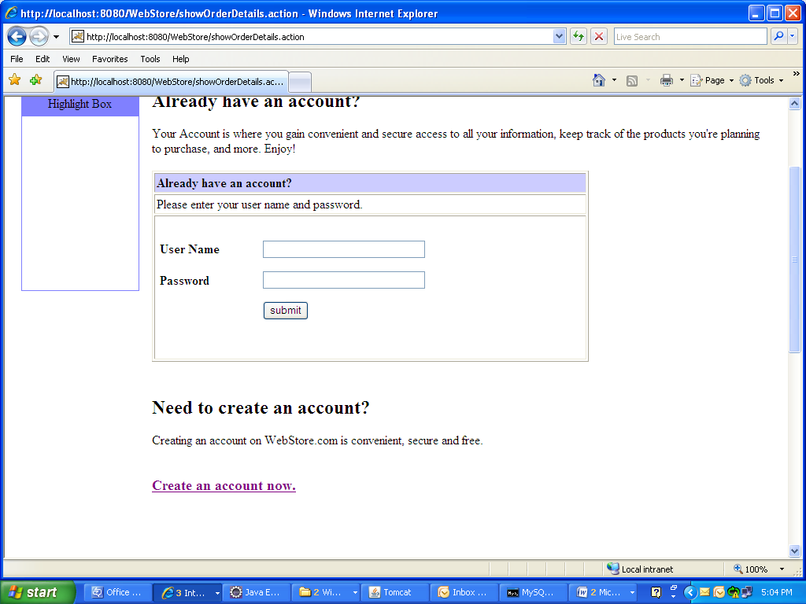

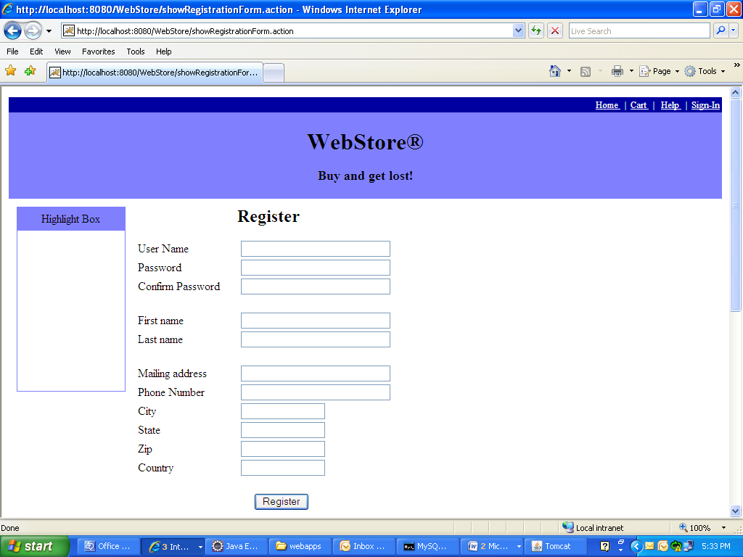

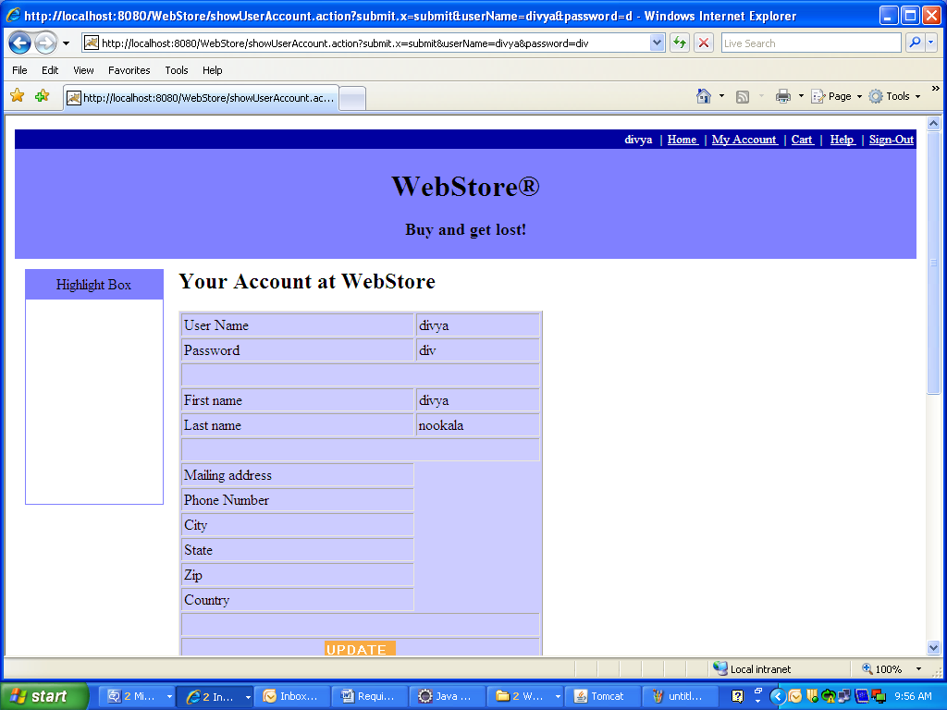
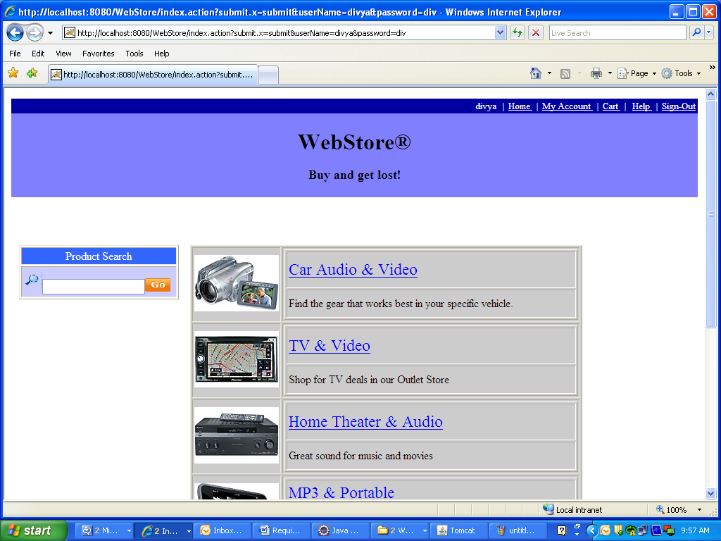
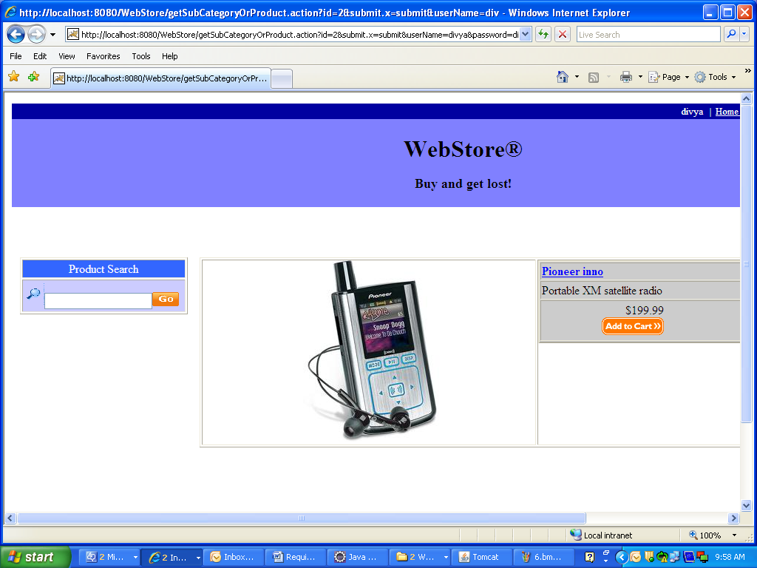

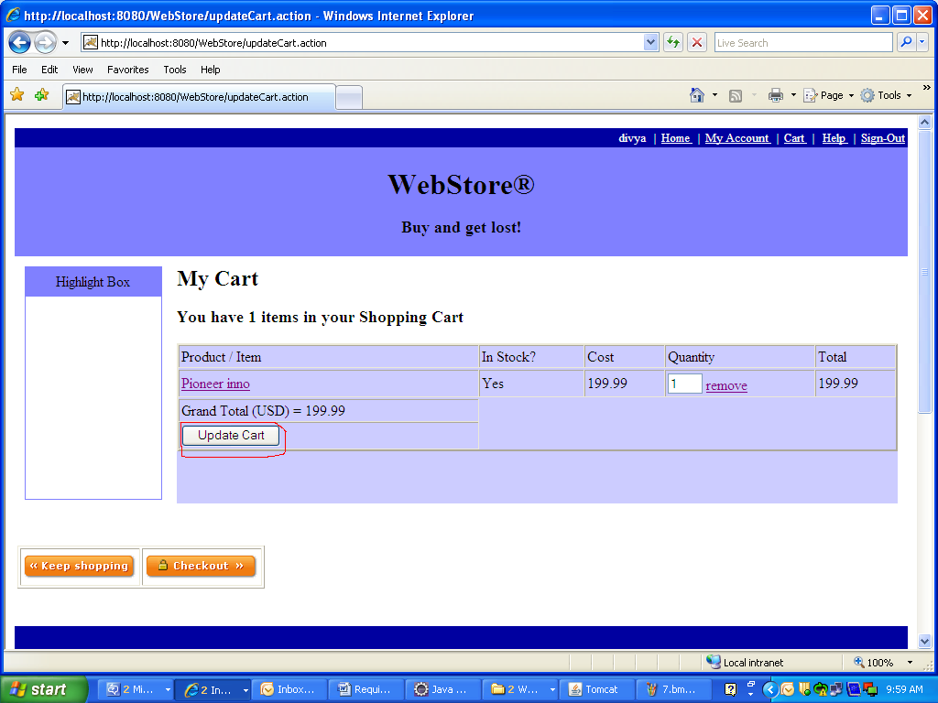
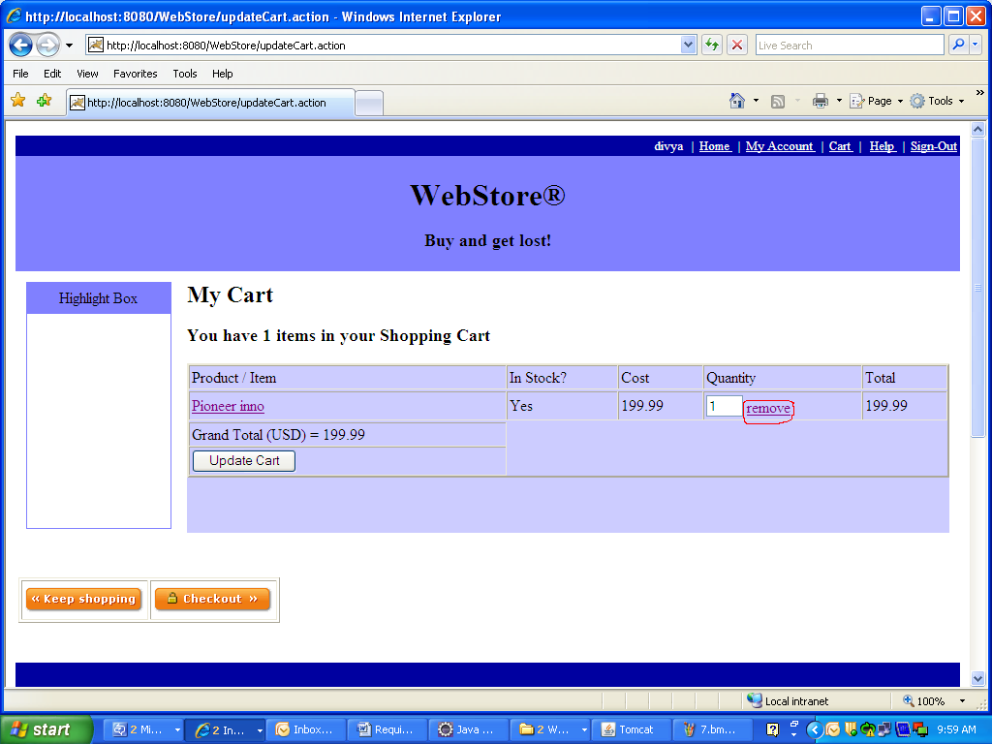

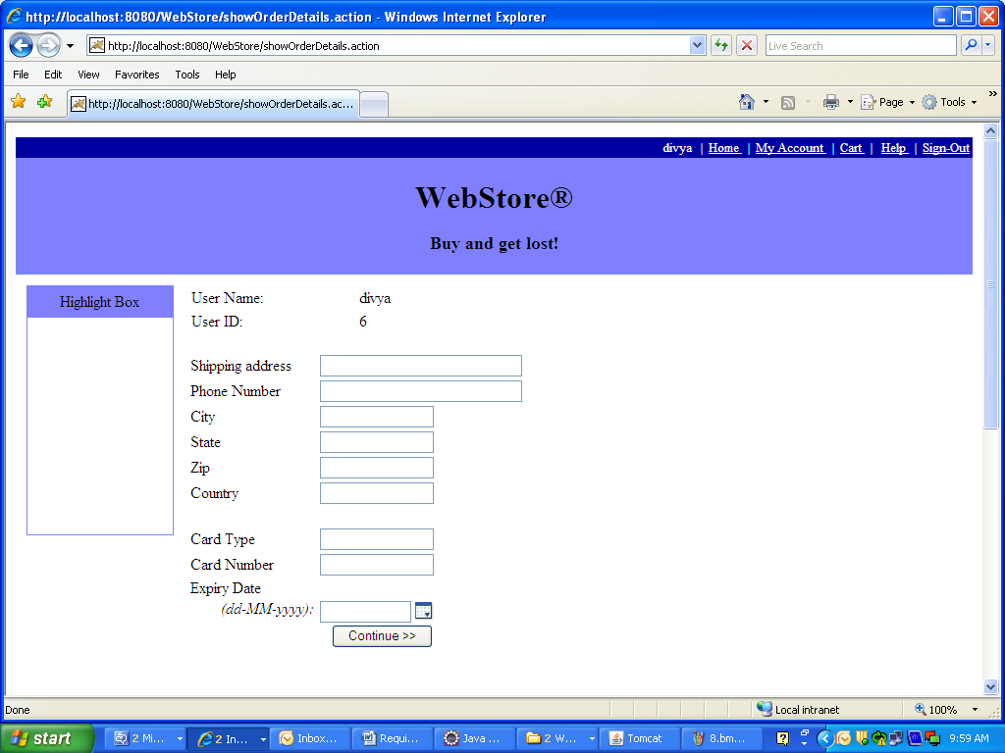

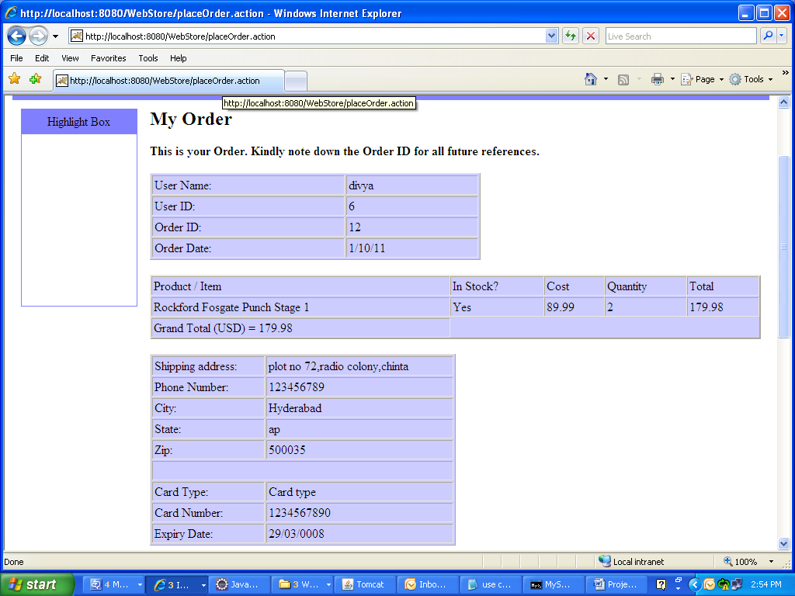

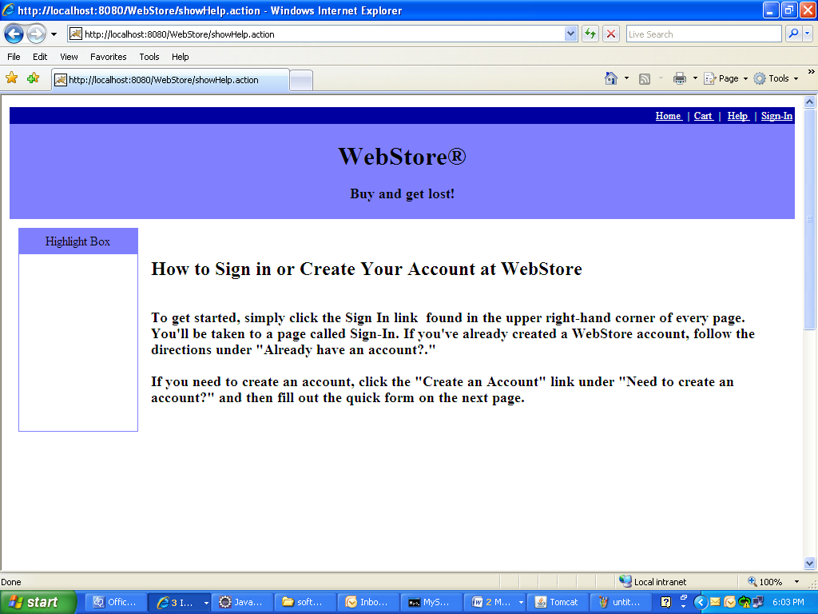

Functional Requirements / System Features

Requirement / Module / Use-case for Log-in
      - Description

This use-case describes the Login page functionality.
REQ-101: The Login page has two fields (One is UserName and the other is Password) and one (Login) button.
REQ-102: The UserName field is marked mandatory and the registered user must enter his/her Username in this field to login.
REQ-103: The Password field is marked mandatory and the registered user must enter his/her Password in this field to login.
REQ-104: Once the registered user enters valid UserName and Password and clicks on Login button, the user will be logged in to his/her account and the user will be directed to Home page displaying the Username of the user on the top of the page.
REQ-105: The login screen provides few links to go to Home page, Cart page, Login page and Help page on top of the page.

4.5.1.2 Screen Flow / Business Flow & User Actions
User enters the Username and password
User will be logged-in to his/her account and cart page will be displayed.
User clicks on Login button
If validated

4.5.1.3 Business Rules & Validations
The business rule to be considered while entering this screen is, the user must be connected to the website and the user must click on Sign-In link.
The business rule to be considered while moving to the next page is that the username and password should be entered and both the fields should be valid.

Requirement / Module / Use-case for Registration

4.5.2.1 Description
This use-case describes the Registration page functionality.
REQ-201: New user can register by clicking on Create an account now. A registration page will be displayed with 13 fields and one button.
REQ-202: The UserName field is marked mandatory and this field will accept letters, digits and any other special symbols. This field accepts maximum of 20 characters only.
REQ-203: The Password field is marked mandatory and this should be at-least 6-8 characters long. It accepts alphabets, numeric’s and special symbols.
REQ-204: The Confirm Password field will be marked mandatory and this should match with the Password.
REQ-205: The FirstName field is marked mandatory and this field will accept only alphabets. This field accepts maximum of 20 characters only.
REQ-206: The LastName field is marked mandatory and this field will accept only alphabets. This field accepts maximum of 20 characters only.
REQ-207: The Date of Birth field is mandatory and this field accepts digits only.
REQ-208: The Email-ID field is mandatory and this field will accept alphabets, digits and two special characters (@ and dot) only.
REQ-209: The Address field is marked mandatory and this field accepts alphabets, digits, special symbols.
REQ-210: The Phone Number field is marked mandatory and this field will accept only digits excluding alphabets and any other special characters.
REQ-211: The City field is marked mandatory and this field will accept only alphabets.
REQ-212: The State field is marked mandatory and this field will accept only alphabets.
REQ-213: The Zip field is mandatory and this field will accept only numbers.
REQ-214: The Country field is mandatory and this field will accept only alphabets.
REQ-215: Once the user enters valid data in all the fields and clicks on Register button, the user will get registered with WebStore and user will be directed to Home page.
REQ-216: The Registration page also provides an option to Login for registered users using the link Sign-In provided at the top of screen and few links to go to Home page, Cart page and Help page etc.

4.5.2.2 Screen Flow / Business Flow & User Actions
User enters all the details required in the registration page.
User will be registered and can be able to purchase/order the products.
User clicks on Register Button.
Checks for validations

4.5.2.3 Business Rules & Validations
The business rule to be considered while entering this page is the user must be connected to Webstore and the user must click on Sign-In link.
The business rule to be considered while moving to next page is that all the mandatory field values must be filled by the user and the data in all the fields should be valid.

Requirement / Module / Use-case for My Account

4.5.3.1 Description
This use-case is describes how to navigate to Logged-in User’s profile page.
REQ-301: Once the user Logs-in to the web store, he/she can view his/her profile by clicking on My Account link. When User clicks on My Account link, the User Information page will be displayed showing all the details of the user which he enters at the time of registration.
REQ-302: The User Information page provides one Update icon at the bottom of the page to change/update his/her profile/details.
REQ-303: This page provides few links to Sign-out from his/her account and to go to Home page, Cart page and Help page provided at the top of screen. This page also provides the flexibility for the user to change his/her Password through the link Change Password.

4.5.3.2 Screen Flow / Business Flow & User Actions
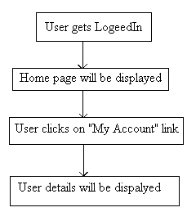

4.5.3.3 Business Rules & Validations
The business rule to be considered while entering this page is the user must Login. The business rule to be considered while moving to the next page is, to make sure that the user clicked on My Account link.

Requirement / Module / Use-case for Home

4.5.4.1 Description
This use case describes about all the available products in the portal.
REQ 401: User clicks on Home link and a page will be displayed showing
All the available Catalogs in the portal along with the images.
REQ-402: User selects any Catalog by clicking on a particular catalog
Image/name and all the available Categories under the selected catalog will be
Displayed along with images.
REQ-403: User selects a category from the resulting categories list by
Clicking on that particular category image/name and all the products/items
Under the selected category will be displayed along with the images, if there are
any products/items available in that category.
REQ-404: User selects a product/item from the resulting products/items
List just by clicking on the image/name of that particular product/item. The product/item will be displayed along with the image, description and price
REQ-405: Home page provides few links to navigate to Home page, Cart page, Login page etc.

4.5.4.2 Screen Flow / Business Flow & User Actions
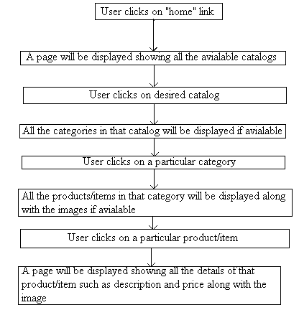

4.5.4.3 Business Rules & Validations
The business rule to be considered while entering this screen is the user must click on Home link.
The business rule to be considered while navigating to the next page is the user must select at least one of the available catalogs.

Requirement / Module / Use-case for Adding to the cart

4.5.5.1 Description
This use case describes adding a product/item to the cart.

REQ-501: Once the user selects a product/item by clicking on that particular product/item, he/she can add them to the cart by clicking on Add to cart icon (which will be present beside that product/item) and after the product is added to cart, the cart page will be displayed showing the details of products/items that are added to cart.
REQ-502: User can get his/her Cart after logging in also, if he adds items to Cart before logging in. But the user cannot get his/her Cart if he logs in after he/she logs out.
REQ-503: User navigates to any page by clicking on any one of the links provided on top of the Cart page and user can navigate to Home page by clicking on Keep Shopping icon in cart page.

4.5.5.2 Screen Flow / Business Flow & User Actions
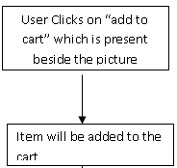

4.5.5.3 Business Rules & Validations
The business rule to be considered while entering this screen is, the user (registered/unregistered) must select a category.
The business rule to be considered while navigating to next page is, the user (registered/unregistered) must add a product to cart.

Requirement / Module / Use-case for updating the cart

4.5.6.1 Description
This use case describes updating the existing cart.
REQ-601: Once the user adds the products to cart, he/she can update the cart (if there are any changes made to cart) by clicking on Update link. If the user changed the quantity of that particular product/item by changing the value in the Quantity field and if the user clicks on update then the cart will be updated with the new quantity which has been set.

4.5.6.2 Screen Flow / Business Flow & User Actions
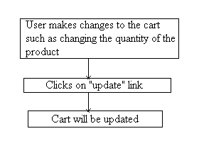

4.5.6.3 Business Rules & Validations
The business rule to be considered while entering this screen is that the user must add at least one item to the cart.
The business rule to be considered when navigating to next page is the user must update the cart.

Requirement / Module / Use-case for removing from the cart

4.5.7.1 Description
This use case describes removing the existing products/items from the cart.
REQ-701: Once the user adds the products to cart, he/she can remove those products/items from the cart by clicking on Remove link.

4.5.7.2 Screen Flow / Business Flow & User Actions
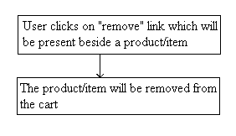

4.5.7.3 Business Rules & Validations
The business rule to be considered while entering this screen is that the user must add at least one item to cart.
The business rule to be considered when navigating to next page is the user must remove at least one product/item from the cart.

Requirement / Module / Use-case for order

4.5.8.1 Description
This use case describes how to order/purchase the products after adding them to cart.
REQ-801: User clicks on Checkout icon to order/purchase the products and billing page is displayed with 13 fields and one button.
REQ-802: The first one is the Shipping Address field and it is marked mandatory. It accepts alphabets, digits and special symbols.
REQ-803: The next field is the Phone Number and it is mandatory. It accepts only digits.
REQ-804: The next is the name of the City and it is mandatory. It accepts only alphabets.
REQ-805: The next field is the State name and it is mandatory. It accepts only alphabets.
REQ-806: The next is the pin code (zip) of the City and it is mandatory. It accepts only digits.
REQ-807: The next field is the name of the Country and it is mandatory. It accepts only alphabets.
REQ-808: The next is the Type of credit card used to pay the price of the product/item purchased and it is mandatory. It accepts only alphabets.
REQ-809: The next field is Card Number and it is mandatory. It accepts only digits.
REQ-810: The next field is the Expiry Date of the card which the user used to pay the price of the item to be purchased and it is mandatory. It accepts only digits and it does not accept special symbols other than hyphen (-).
REQ-811: Once the user enters valid address, city, state, country, zip, card details and clicks on Continue button, a (Order) page will be displayed showing all the details about the order and the user will be provided with a unique order id to track his order.
REQ-812: User will be provided with few links to navigate to Home page, Help page, Cart page, Profile page (by clicking on My Account link) and two more links to Sign-Out from his/her account and to change his/her Password.
If user wants to make one more order then he/she can do so by clicking on Home icon provided at the bottom of this page.

4.5.8.2 Screen Flow / Business Flow & User Actions
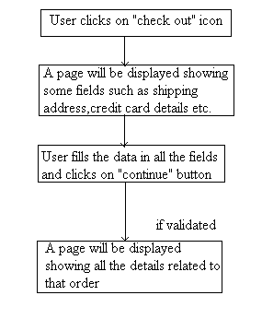

4.5.8.3 Business Rules & Validations
The business rule to be considered while entering this page is the user must click on Check out icon.
The business rule to be considered while navigating to next page is the user must provide valid data in all the fields and the user must click on Continue button.

Requirement / Module / Use case for help

4.5.9.1 Description
This use case is used to guide a new user.
REQ-901: If a new user visits the website then he will be guided using this use case. When the user clicks on Help link, a page will be displayed guiding the user how to login to and register with Web store.

4.5.9.2 Screen Flow / Business Flow & User Actions
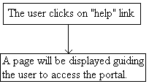

4.5.9.3 Business Rules & Validations
The business rule to be considered while entering this page is, the user must be able to connect to Web store and the user must click on Help link.

Requirement / Module / Use case for logout

4.5.10.1 Description
This use case describes the logout action.
REQ-1001: This use case describes about the security reasons so that no other unauthorized user can access the previous user account. After the user clicks on Sign-Out link, the user will be directed to Login page and the previous user’s session will be set to null.

4.5.10.2 Screen Flow / Business Flow & User Actions
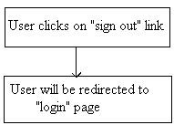

4.5.10.3 Business Rules & Validations
The business rule to be considered while entering this page is the user must be logged in to his account.

Performance Requirements
REQ-1005: Providing safety for the details which the user enters during registration and during shipping interface.
REQ-1106: The system should not crash when multiple users are accessing the portal at a time.
REQ-1109: The response time of the system is approximately 1-2 seconds.
REQ-1110: Providing the access to the web portal at all times.

Acceptance Criteria
The above mentioned requirements are the acceptance criteria for the system.

Logical Database Requirements

E-R Diagram
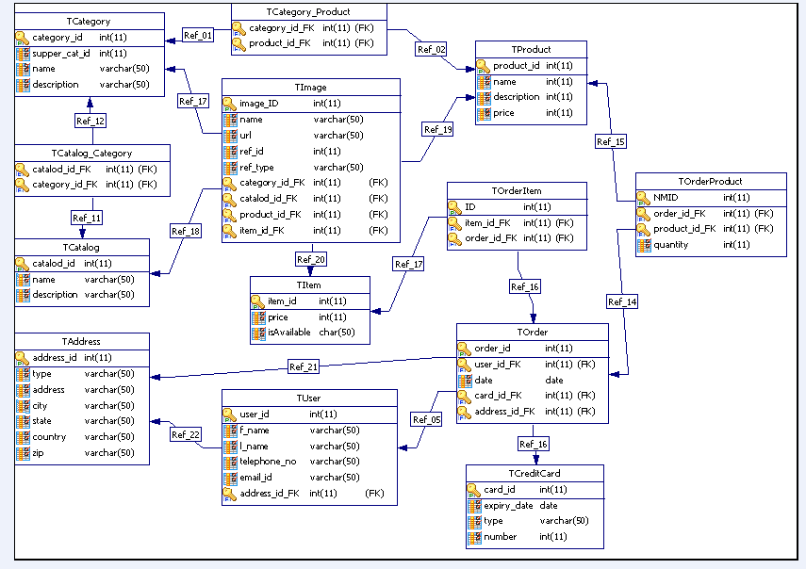

Design Constraints
It can be run on any server like
- Apache Tomcat,
- Jboss server etc.

Testing Requirements
Please refer to the attached testing requirements document.

Compliance to Standards
NA

Software System Attributes
Functionality
The user can browse through the website for selecting the catalogs categories, subcategories, products; items required for purchasing .he/she can select necessary items in the cart. From the cart he/she can even remove or update the products. These all are the functionalities which are fulfilling the need of the customer.
Suitability
NA
Accuracy
The images, descriptions and prices given in the online portal accurately resemble the original items/products.
Interoperability
NA
Security
The system provides highly secured authentication. The user details which are given during registration, shipping details and credit card information are secured safely.
Reliability
The Web server of the portal is accessible to all kind of customers.
Maturity
NA
Fault tolerance
NA
Recoverability
The details of the products selected into the cart remains in the cart when the user system is abruptly closed, this enhances the recoverability of the system.
Reliability compliance
NA

Usability
- The Home Page is provided with a good overview of all the main key products on sale of the site as well as clearly highlighting information and products to encourage site visitors to review the product ranges and special offers.
- The product categories are also available throughout the site as part of the navigation system to give customers constant access to all the products available and allow the user move easily through the product options.
Understandability
In order to make user Understandable with the operation of the web portal all instructions have been given in the help link which is present on the right corner of the home page.
Learn ability
The Web store portal is designed in such a way that the user can learn about many products without much physical strain.
Operability
There are links provided on the right corner throughout the site as part of the navigation system to give customers constant access to all the web pages available and allow the user move easily through the product options.
Attractiveness
In order to attract the users for accessing the website the home page of the portal comprises of advertisements which provides discounts on purchase of 2 or more products etc.
Usability compliance
NA
Efficiency
Providing the access of the web portal on all times.
It offers 24/7 technical support.
Time Behavior
NA
Resource Utilization
NA
Efficiency Compliance
NA
Maintainability
NA
Analysability
NA
Changeability
NA
Stability
NA
Testability
Each and every field entered by the user is validated to provide secured authentication.
Maintainability Compliance
NA
Portability
It can be accessed on any platform.
Adaptability
NA
Installability
NA
Co-existence
NA
Replaceability
NA
Portability Compliance
NA
Availability
Providing the access of the web portal on all times.
It offers 24/7 technical support.
Safety
The user details which are given during registration, shipping details and credit card information are secured safely.
Environmental
It can run either on Jboss server or ApacheTomcat server environment.
Other Requirements
There are no other requirements apart from the above mentioned requirements

Statutory and Regulatory Requirements
The system does not have any statutory and regulatory requirements.

Organizing Specific Requirements
NA

Derived Requirements
They are no derived requirements for Webstore Application project.

Validation

Validation strategy
JUnit testing and GUI testing are used to validate the functionality and requirements of web store.

Validation criteria
- Accuracy

- Linearity

- Awareness

- Architecture

Validation Constraints
User can order maximum of 999 items\products of particular type at a time.
Web store runs on intranet only.
More than 100 users cannot access the website at same time.

References
1. CF_PL_J2EE_WebStoreProject_FunctionalTestCases.xlsx document.
2. Guidance from real-time online shopping Website

